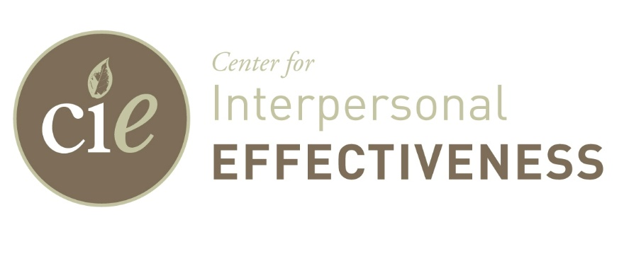

The Center for Interpersonal Effectiveness (CIE) is an association of independent mental health practitioners who provide assessment and psychotherapy services to child, adolescent, adult, and geriatric populations. We currently seek a competent and independent Iowa licensed mental health clinician (LISW/LMHC/PH.D./PSY.D) to join our busy, well-established affiliate group practice. Both full and part-time opportunities are now being considered. We have a satellite office in Newton with our primary office located in the fast-growing community of Ankeny. Play therapy and testing rooms available. Most of the current clinicians operate their practices in a hybrid model to offer clients both office and telehealth formats. Our office building is professional and support staff are dedicated to the success of each clinician’s private practice. We have a growing referral base for child and adolescent services as well as couples/marital counseling. Therefore, preference will be given to applicants with clinical interest in those areas. However, we will consider any interested licensed applicant who is eligible on multiple insurance panels.

If the opportunity to establish your own private practice among an exceptional group of independent mental health professionals and excellent support staff is of interest to you, send a letter of interest and vitae to: R. James Thorpe, Psy.D. Center for Interpersonal Effectiveness, 2525 N. Ankeny Blvd. Suite 113 Ankeny, IA  50023 /[515-289-9136](tel:%20515-289-9136) (P) [515-289-9139](tel:515-289-9139) (FX)  [jimthorpe@cie-ankeny.com](mailto:jimthorpe@cie-ankeny.com).  Please visit our website at [www.cie-ankeny.com](http://www.cie-ankeny.com/) for more information about CIE.